Fuctie aanmaken:

Voor aan te passen als je het niet hebt opgeslaan:

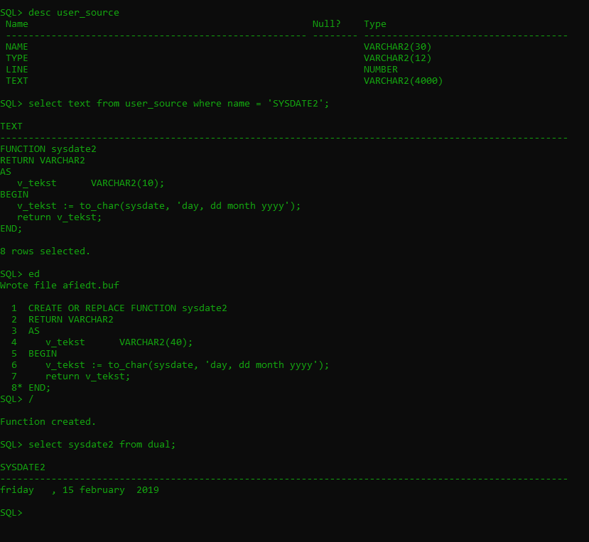

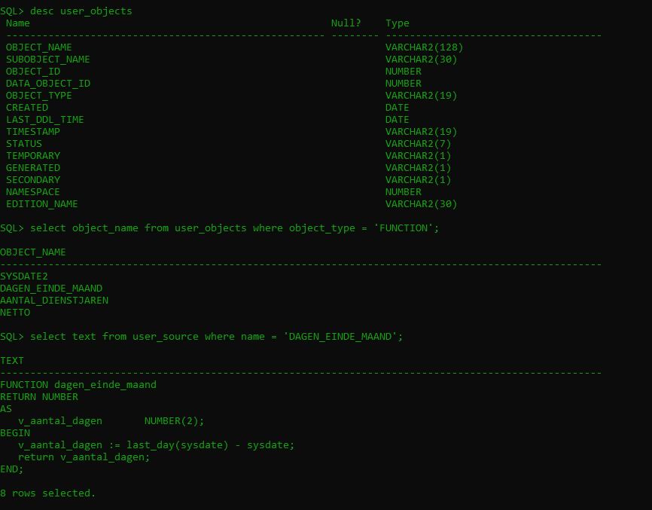

Hoofdstuk 2 oefeningen blackboard

Opgave1:

CREATE OR REPLACE FUNCTION dagen_einde_maand

RETURN NUMBER

AS

v_aantal_dagen NUMBER(2);

BEGIN

v_aantal_dagen := last_day(sysdate) - sysdate;

return v_aantal_dagen;

END;

En daarna het volgende voor het aantal dagen te krijgen

select dagen_einde_maand from dual;

opgave 2:

CREATE OR REPLACE FUNCTION aantal_dienstjaren

(p_date IN date)

RETURN NUMBER

AS

BEGIN

RETURN trunc(months_between(sysdate, p_date) / 12);

END;

select aantal_dienstjaren(hire_date), last_name from employees;

opgave 3a:

CREATE OR REPLACE FUNCTION netto

(p_salary employees.salary%type)

RETURN VARCHAR2

AS

BEGIN

RETURN to_char(p_salary * 0.6, '999,999,999.00') || ' euro';

END;

select netto(salary) from employees;

opgave 3b:

CREATE OR REPLACE FUNCTION netto

(p_bruto employees.salary%type)

RETURN VARCHAR2

AS

v_netto employees.salary%type;

BEGIN

IF p_bruto <= 10000 then

v_netto := p_bruto * 0.6;

ELSIF p_bruto <= 160000 then

v_netto := 6000 + (p_bruto - 10000) * 0.5;

ELSE

v_netto:= 6000 + 3000 + (p_bruto - 16000) * 0.4;

END IF;

RETURN to_char(v_netto, '999,999,999.00') || ' euro';

END;

select netto(salary) from employees;

opgave 4b:

CREATE OR REPLACE FUNCTION schrikkeljaar

(p_jaar NUMBER)

RETURN VARCHAR2

AS

BEGIN

IF mod(p_jaar , 400) = 0 OR ( mod(p_jaar, 4) = 0 AND mod(p_jaar, 100) != 0) THEN

RETURN p_jaar || ' is een schrikkeljaar';

ELSE

RETURN p_jaar || ' is geen schrikkeljaar';

END IF;

END;

/

Opgave 5:

CREATE OR REPLACE FUNCTION volgende_vergadering

RETURN DATE

AS

v_datum date;

BEGIN

v_datum := next_day(last_day(sysdate), 'monday');

IF to_char(v_datum, 'ddmm') = '0101' OR to_char(v_datum, 'ddmm') = '0105' THEN

v_datum := v_datum + 1;

END IF;

RETURN v_datum;

END;

select volgende_vergadering from dual;

Opgave 6:

CREATE OR REPLACE FUNCTION next_employee_id

RETURN number

AS

v_id number(3);

v_max number(3);

BEGIN

select max(employee_id)

into v_max

FROM employees;

v_id := v_max + 1;

return v_id;

END;

Select next_employee_id from dual;

Opgave 7:

CREATE OR REPLACE FUNCTION berekening_bruto_jaarloon

(p_emp_id employees.employee_id%type)

RETURN number

AS

v_bruto employees.salary%type;

BEGIN

select(salary * NVL(commission_pct + 1,1))*12

into v_bruto

from employees

where employee_id = p_emp_id;

return v_bruto;

END;

select berekening_bruto_jaarloon (100) from dual;

Opgave 8:

CREATE OR REPLACE FUNCTION manager_meeste_werknemers

RETURN varchar2

AS

v_voornaam varchar2(40);

v_naam varchar2(40);

BEGIN

select d.department_id, count(e.employee_id)

into v_depid, v_countemp

from departments d join employees e

group by d.department_id

having count(e.employee_id) = (select max(count(department_id)) from employees group by department_id);

select first_name, last_name

into v_voornaam, v_naam

from departments d join employees e

return v_voornaam || ' ' || v_naam;

END;

/

Hoofdstuk 3 oefeningen blackboard

**Oefening 1:**

CREATE OR REPLACE PROCEDURE toon_laatste_emp

IS v_employee_id employees.employee_id%type;

v_employee_first_name employees.first_name%type;

v_employee_last_name employees.last_name%type;

v_employee_hire_date employees.hire_date%type;

BEGIN

SELECT employee_id, first_name, last_name, hire_date

INTO v_employee_id, v_employee_first_name, v_employee_last_name, v_employee_hire_date

FROM employees

WHERE hire_date = (SELECT(MAX(hire_date)) FROM employees);

DBMS_OUTPUT.PUT_LINE(v_employee_id || ' ' || v_employee_first_name || ' ' || v_employee_last_name || ' ' || v_employee_hire_date);

END toon_laatste_emp;

/

exec toon_laatste_emp

**oefening2:**

CREATE OR REPLACE PROCEDURE grootste_dept

IS v_dept_name departments.department_name%type;

v_emp_first_name employees.first_name%type;

v_emp_last_name employees.last_name%type;

v_emp_salary employees.salary%type;

BEGIN

SELECT d.department_name, e.last_name, e.first_name, e.salary

INTO v_dept_name, v_emp_last_name, v_emp_first_name, v_emp_salary

FROM employees e

JOIN departments d on e.department_id = d.department_id

WHERE e.department_id = (SELECT department_id

FROM employees

GROUP BY department_id

HAVING count(department_id) = (SELECT MAX(COUNT(department_id)) FROM employees GROUP BY department_id))

AND e.salary = (SELECT MAX(salary)

FROM employees

WHERE department_id = e.department_id);

DBMS_OUTPUT.PUT_LINE(v_dept_name || ' ' || v_emp_last_name || ' ' || v_emp_first_name || ' ' || v_emp_salary);

END grootste_dept;

/

**Na code van slide 17: (anoniem blok)**

DECLARE

v_aantal number(3);

BEGIN

raise_salary_2_dept('Administration', 5, v_aantal);

DMBS_OUTPUT.PUT_LINE('aangepaste records: ' || v_aantal);

END;

/

variable b_aantal number

exec raise_salary_2_dept('Administration', 8, :b_aantal)

print b_aantal

desc raise_salary_2_dept

**oefening3:**

CREATE OR REPLACE PROCEDURE minimumlonen

(p_landnaam IN countries.country_name%TYPE

, p_nieuw_minimumloon IN employees.salary%TYPE)

AS

BEGIN

UPDATE employees

SET salary = p_nieuw_minimumloon

WHERE department_id IN (SELECT e.department_id

FROM employees e join departments d

on e.department_id = d.department_id

join locations l

on d.location_id = l.location_id

join countries c

on l.country_id = c.country_id

WHERE country_name = p_landnaam)

AND salary < p_nieuw_minimumloon;

END;

/

exec minimumlonen('Canada', 6250);

**extra opgave:**

CREATE OR REPLACE PROCEDURE testloop

AS

BEGIN

FOR emprec IN ( SELECT department_id, first_name, last_name

FROM employees

WHERE department_id BETWEEN 10 AND 50

ORDER BY department_id) LOOP

DBMS_OUTPUT.PUT_LINE(emprec.department_id || ' ' || emprec.last_name || ' '|| emprec.first_name);

END LOOP;

END;

exec testloop

**oefening4:**

CREATE OR REPLACE PROCEDURE minimumlonen

(p_landnaam IN countries.country_name%TYPE

, p_nieuw_minimumloon IN employees.salary%TYPE

, p_countrows OUT NUMBER)

AS

BEGIN

UPDATE employees

SET salary = p_nieuw_minimumloon

WHERE department_id IN (SELECT e.department_id

FROM employees e join departments d

on e.department_id = d.department_id

join locations l

on d.location_id = l.location_id

join countries c

on l.country_id = c.country_id

WHERE country_name = p_landnaam)

AND salary < p_nieuw_minimumloon;

p_countrows := sql%rowcount;

END;

/

**Oproepen via anoniem block**

**Eerst:** eenmalig: set autoprint on

declare

v_aantal number;

begin

minimumlonen('Canada', 6270, v_aantal);

dbms_output.put_line(v_aantal);

end;

/

**Via bind variable:**

variable b_aantal NUMBER

exec minimumlonen ('Canada', 6280, :b_aantal)

Hoofdstuk 4 oefeningen blackboard

bus -> before update statement

**oefening 1:**

CREATE OR REPLACE TRIGGER bus_jobs

BEFORE UPDATE

ON jobs

BEGIN

IF USER in ('STUDENT', 'BEZOEKER') THEN

RAISE_APPLICATION_ERROR(-20000, 'Je hebt onvoldoende rechten om deze actie uit te voeren!');

ELSE

DBMS_OUTPUT.PUT_LINE('ben je zeker? anders doe ROLLBACK');

END IF;

END;

/

update jobs set job_title='qksdjfqdksjfllkqdf';

**oefening 2:**

CREATE table log_history(

log_user varchar2(20),

log_tijdstip date,

log_actie varchar2(20))

CREATE OR REPLACE TRIGGER auids_jobhis

AFTER UPDATE OR INSERT OR DELETE

ON job_history

DECLARE

v_actie varchar2(20);

BEGIN

IF UPDATING THEN

v_actie := 'update';

ELSIF DELETING THEN

v_actie := 'delete';

ELSIF INSERTING THEN

v_actie := 'insert';

END IF;

INSERT INTO log_history

VALUES(USER, sysdate, v_actie);

END;

/

**oefening 3:**

CREATE OR REPLACE TRIGGER buid

BEFORE UPDATE OR INSERT OR DELETE of salary

ON employees

BEGIN

IF UPDATING AND NOT(TO_CHAR(sysdate, 'hh24') >= 9 AND TO_CHAR(sysdate, 'hh24') < 17 AND TO_CHAR(sysdate, 'DAY') = 'MONDAY') THEN

RAISE_APPLICATION_ERROR(-20000,'Je mag enkel maandag tussen 9u00 - 17u00 aanpassen');

END IF;

IF DELETING OR INSERTING AND TO_CHAR(sysdate, 'DAY') IN ('SATURDAY', 'SUNDAY') THEN

RAISE_APPLICATION_ERROR(-20001,'Je kan in het weekend geen employees verwijderen of toevoegen');

END IF;

END;

/